CDIF-4-XAS: Mappings from Community Standards to CDIF

Introduction
This document and the associated spreadsheet and other materials present an initial attempt to take the major community standards used for X-Ray Absorption Spectroscopy (XAS) and map them to the standards recommended for cross-domain FAIR sharing of data by the Cross Domain Interoperability Framework (CDIF) guidelines. The current standards landscape within the XAS community has been extensively described in the document “Overview of X-Ray Absorption Spectroscopy standards, vocabularies (and ontologies), data formats and practices”. This document builds on the analysis presented in that document as a concrete exploration of how the data and metadata from the two most common XAS standards can be expressed in a CDIF-described package to facilitate use across domain, institutional, and application boundaries. It is felt that a concrete application of the standards and guidelines involved will clearly indicate the next steps for implementation.
While the focus of this document is technical, there are also implications for how other activities by domain groups and standards bodies can most effectively be conducted. These implications can be provided as feedback to various groups, and these will be mentioned here. The specific recommendations to be made to such groups do notform part of this deliverable, but will be formulated more completely in other project deliverables in the future.

Existing Standards and Scenarios of Use
The document “Overview of X-Ray Absorption Spectroscopy standards, vocabularies (and ontologies), data formats and practices” clearly identifies two major standards within the XAS community which have become the focus for harmonization of data description and formatting. The first of these is the NeXus format, using HDF5 as the data format and the NXxas application profile to hold relevant metadata and description. The second standard is the XDI standard, which describes a text-based format for both metadata and data. Both of these are described in this document in “Section 5.1 Community defined standards”.
It should be noted that these two standards are used for different things: NXxas is used to describe the raw data resulting from one or more measurements or scans. While it can have additional application data added to it or linked from it, it builds on the raw data which it describes for these functions. It is used as a means of exchanging the raw data between applications, a task which may involve large amounts of data. Consequently, HDF5 has emerged as the best way to package the data in these scenarios.
XDI is focused in the analytical aspects of XAS. It is designed to “encapsulate a single spectrum of XAFS along with relevant metadata.” (p. 49) The intention here is to provide this data for exchange between analysis programs, spreadsheets, and data visualization tools. In practical terms, the volume of data to be expressed as XDI is much smaller than that for NXXas, so both the data and metadata are combined in a single text-based format.
From the perspective of CDIF, the goal is to allow any potential users of the data to find and assess the data for FAIR purposes, which involves understanding what is in the data sets described. Further, it should be possible to programmatically access the data and transform it into the form necessary for reuse. This “FAIR” functionality is independent of the specific processes supported by the different XAS community standards, but relies on the information contained in those standard formats (as well as some additional information for cataloguing purposes.) These FAIR functions, however, are very much aligned with the stated goals of those who produce the community standards, as we see in their stated goals (p. 43):
- The benefits of data integration should be not only in data-driven science but also in
everyday research.
- The data and metadata should be in as few formats as possible (ideally following an
- agreed data schema).
- The publication infrastructure should be prepared as a repository with policies for
data utilization, such as the FAIR Principles.
- The database infrastructure should have search functionality and not just storage
online.

For the purposes of the current mapping exercise, two major scenarios emerge: (1) a data set encoded in HDF5 according to the NXxas application profile of NeXus will be documented using a “cross-domain” CDIF metadata description to accompany the HDF5 file; and (2) an XDI text file will have its data contents described using the “cross-domain” CDIF recommendations for needed metadata. In both cases, the consumer of the data might be ignorant of the source formats – that is, their systems might not be designed to work with the standards employed. Regardless, they should be provided with enough information to maximise the machine-accessibility of these data, and to support search and other FAIR functions.
It should be noted that within the XAS community, cataloguing metadata is generally held external to the data files, and this is largely true of both the community standards described here. CDIF combines the cataloguing and data description metadata into a singe format for FAIR purposes, and in these cases the XAS data will often be supplemented by cataloguing metadata held in typical “standard” formats such as the DataCite metadata scheme. Additionally, the entire package may need to be supplemented with information regarding access, licensing, and fair use. Such information often comes from institutional policy guidance, and may not be expressed in a standard form.

One requirement of CDIF which is not fully met by existing community standards is the need for formal definitions of the concepts used in describing the data. These can be exposed as labels for columns of fields and similar descriptors of data. CDIF demands that these be described in a standard fashion, because FAIR users may be unfamiliar with the use of terms in the institution which has produced the data. While there are some formal definitions in the XAS community specifications, these are not expressed in a standard or comprehensive form. They can, however, form the basis of such an expression.

Note that CDIF metadata is always expressed in a JSON-LD syntax, optimized for use in FAIR reuse over the Web. It leverages both the familiar Javascript features of JSON, as well as the more powerful RDF features of Linked Data approaches.

The standards recommended by CDIF include Schema.org (for cataloguing and discovery), W3C PROV for provenance information, W3C SKOS for controlled vocabularies, and the data Description Initiative’s Cross-Domain Integration (DDI-CDI) specification. All of these specifications are used according to profiles described in the CDIF guidelines, although the provenance guidelines are currently under development.
CDIF currently focuses on describing data sets encoded in text-based formats. The need to describe binary formats (including HDF5) has been noted in the initial release of the guidelines, and work in this area is on-going.

Inputs and Outputs
Given the scenarios described above, we can produce high-level schematics of the transformation processes which will be supported. These should make the spreadsheet mappings easier to follow, as there are several different inputs and outputs involved.

XDI-to-CDIF
The schematic below shows the mapping from XDI to the CDIF recommended specifications:
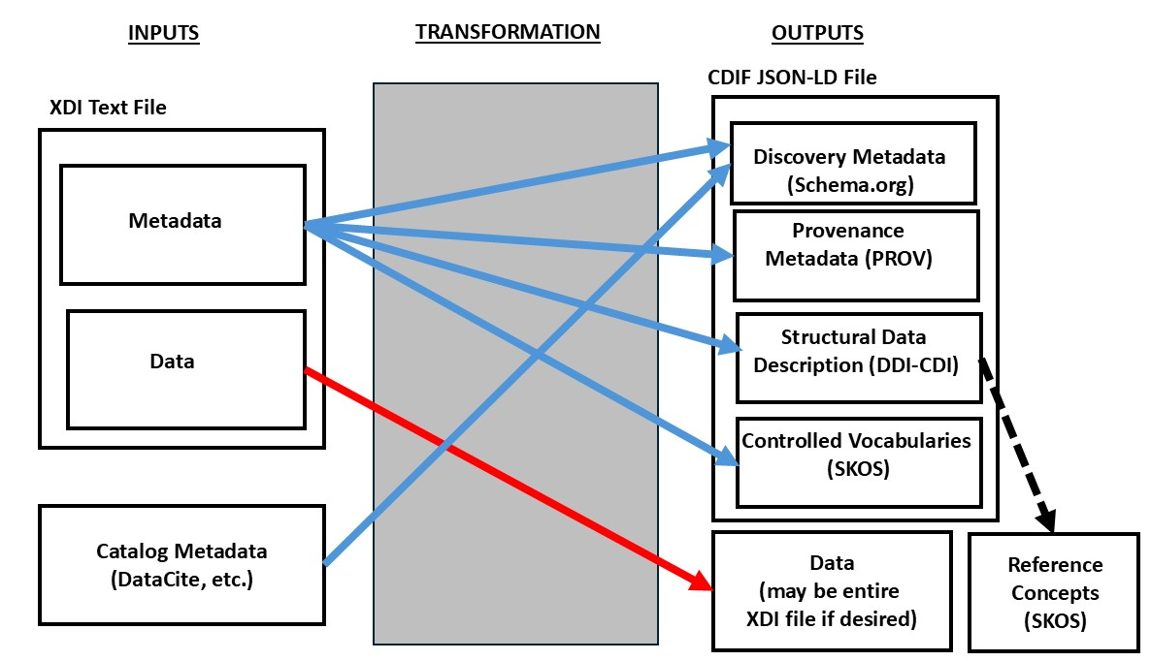
The inputs include an XDI file, which contains both a metadata section and a data section, and a set of cataloguing metadata (such as a DataCite file). The XDI file may be “passed through” the transformation to act as a data file in the resulting package, or the data may be pulled out and reduced to a simple data-only text file. The metadata is transformed in either case, and placed in different areas of the CDIF metadata, based on what type of information it is. The cataloguing metadata is a fairly straightforward mapping into corresponding Schema.org fields.
Note that CDIF uses SKOS to describe enumerated cause found in the data – this is the set of controlled vocabulary metadata inside the CDIF JSON-LD package. (The dashed line indicates the use of these concepts using links.) The Reference Concepts are a static set of terms drawn from authoritative sources within the XAS community (or from authorities recognised by that community). These are expressed as SKOS concepts in a SKOS concept scheme that would be published externally to the CDIF package, so a single set of definitions can be reused.
Note that the resulting resources are completely “open” in that they are all expressed in open standard formats or as structured text (for the data). No proprietary software is needed to access the files, and all of the standards are Web-based (JSON-LD/RDF, text) so that it is as easy as possible to access and use the resulting metadata. From a FAIR perspective, this is ideal, and very much in line with best practice as endorsed by the CDIF guidelines. The provided metadata is also very rich, giving complete definitions of terms, and indicating the structure and semantics of the data in a (potentially) comprehensive fashion.

NXxas-to-CDIF
The schematic below shows the mapping of NXxas HDF5 files to the CDIF-recommended specifications:
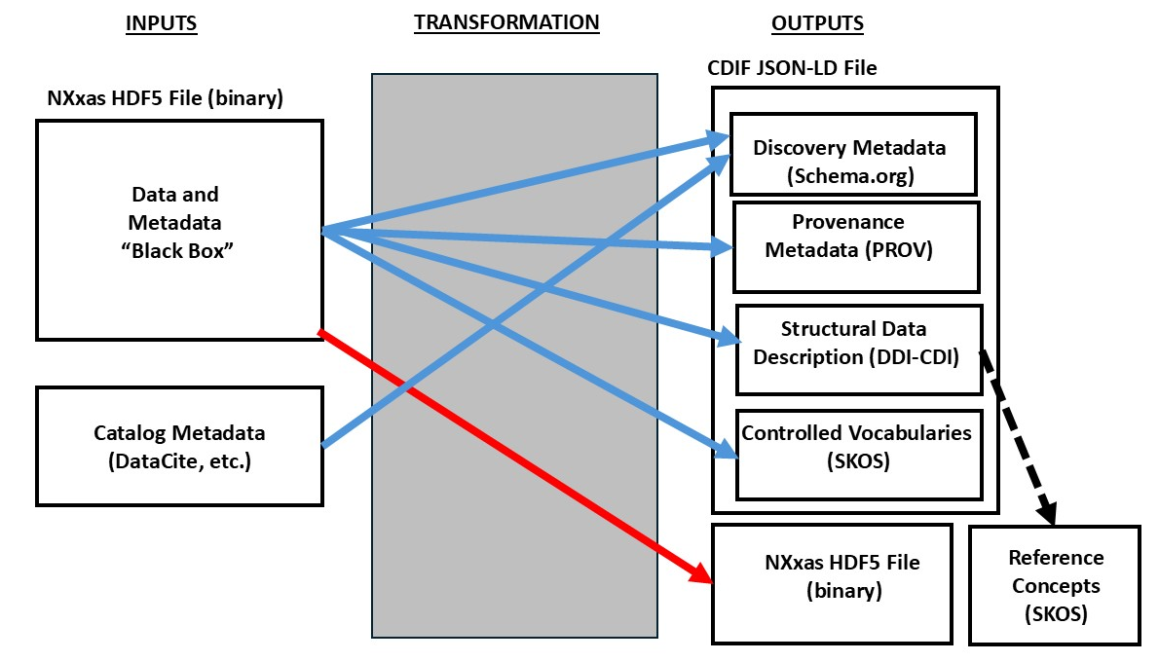
This mapping is very similar to the XDI mapping. The big difference is that the data are in a binary format – the HDF5 source file. All data are referred to from the metadata using path expressions which can be resolved by HDF5 software packages. The metadata is all stored in “open” JSON-LD form, as for the XDI metadata.
As before, the static reference concepts are expressed as SKOS, published separately, and the cataloguing metadata is (at least in part) coming from DataCite or some other standard cataloguing metadata format.
It should be noted that the relative assignment of metadata from NXxas to CDIF is quite different than with XDI. Because NXxas is focused on describing large sets of raw data, the data description is quite different than the simple descriptions found with the XDI data. Further, there is a wealth of information regarding the sample and collection of the measurements, which is not necessarily present in the XDI format. Much of this metadata is expressed in PROV in the CDIF package, which is not as heavily used in the XDI mapping.
The biggest difference here is that, from a FAIR perspective, the need to have dedicated HDF5 software to access the data makes this slightly less open. Granted, HDF5 is a standard format, and there are free tools, but the practical cost os accessing the data for those who do not already use HDF5 is higher than with the XDI mapped data, because there is a requirement for more than just Web-oriented technologies. Despite this, both CDIF output packages have very rich metadata which is equally open, and from this perspective both are ideally FAIR.

Static Concept Definitions
The production of the Reference Concepts is performed in an off-line fashion. For this deliverable, we offer a draft set of concept definitions coming from the NXxas specifications, XDI, IUCr, and IUPAC. This is provided both as a human-readable spreadsheet, and in a machine-processible SKOS form (which is equivalent). Ideally, this set of Reference Concepts would be agreed by the community in a process lead by the existing standardization groups. Once agreed, a single canonical version – including SKOS – could be published for use not just by CDIF but by all members of the community for any application where it proved useful. Agreed definitions are a foundational aspect of FAIR, and this includes their expression in a standard, machine-actionable form.
It should be noted that while we are using SKOS here, an ontology described in OWL would be another form of publication which would be fundamentally in line with the FAIR principles. Because SKOS is a more accessible standard format in many domains, it is preferred for the purposes of the CDIF guidelines. Both standard forms could be published in an aligned form for different applications.

Further Work
Several work items or issues have arisen from the initial mapping work and the discussions held during its development. In this section, these are briefly noted, with the intention that these will lead to specific actions as appropriate later in the project.
- New Data Description Features of DDI-CDI: In this mapping, it became clear that there was a concrete requirement to be able to describe the HDF5 binary data file using the DDI-CDI metadata recommended by CDIF. This was a feature already targeted by the CDIF Working group as a priority, and it is hoped that the NXxas use case can serve as one significant input to that development. We believe that the approach taken here is in line with the overall design of CDIF in implementing support for the FAIR Data Principles.
- Extensions to the DDI-CDI Profile in CDIF: Additionally, there may be some minor extensions to the CDIF profile of DDI-CDI which are needed, for the inclusion of classes which are required for XAS data bit which were not in the current set of CDIF recommendations.
- Contributions to the CDIF Provenance Profile: The CDIF Working Group is now focusing on data provenance and context, and part of what was used in these mappings comes from drafts of an extension to PROV being developed as part of the CDIF work. The requirements coming from this mapping are in line with the approach being taken by CDIF, and it is intended that the XAS use case be provided to that group, so that it can be directly addressed by the emerging solution in the CDIF recommendations as they evolve.
- Engaging the XAS Community in Publishing FAIR Reference Concepts: This mapping has highlighted the need for agreed formal concept definitions within the domain. Further, it has provided an example of how these might be expressed as a machine-actionable resource, based on a draft taken from existing sources. This project cannot do more than advocate for the development of a real set of agreed reference concepts, but we intend to make the effort to promote this idea to the appropriate domain authorities, and in general to support the development of such a resource in line with FAIR implementation.

https://doi.org/10.5281/zenodo.14920226
ibid
https://doi.org/10.5281/zenodo.14920226
ibid
3.3.2.26. NXxas — nexus v2024.02 documentation
XAS-Data-Interchange/specification/spec.md at master · XraySpectroscopy/XAS-Data-Interchange · GitHub

